|  |  |
| --- | --- |
| Activity | Data Type |
| Number of beatings from Wife | Discrete |
| Results of rolling a dice | Discrete |
| Weight of a person | Continuous |
| Weight of Gold | Continuous |
| Distance between two places | Continuous |
| Length of a leaf | Continuous |
| Dog's weight | Continuous |
| Blue Color | Discrete |
| Number of kids | Discrete |
| Number of tickets in Indian railways | Discrete |
| Number of times married | Discrete |
| Gender (Male or Female) | Discrete |

Q1) Identify the Data type for the Following:

Q2) Identify the Data types, which were among the following

Nominal, Ordinal, Interval, Ratio.

|  |  |
| --- | --- |
| Data | Data Type |
| Gender | Nominal |
| High School Class Ranking | Ordinal |
| Celsius Temperature | Interval |
| Weight | Ratio |
| Hair Color | Nominal |
| Socioeconomic Status | Ordinal |
| Fahrenheit Temperature | Interval |
| Height | Ratio |
| Type of living accommodation | Ordinal |
| Level of Agreement | Ordinal |
| IQ(Intelligence Scale) | Ratio |
| Sales Figures | Ratio |
| Blood Group | Nominal |
| Time Of Day | Interval |
| Time on a Clock with Hands | Interval |
| Number of Children | Nominal |
| Religious Preference | Nominal |
| Barometer Pressure | Interval |
| SAT Scores | Interval |
| Years of Education | Ratio |

Q3) Three Coins are tossed, find the probability that two heads and one tail are obtained?

Ans) Total number of events= (hhh, hht. htt. ttt. tth. thh. hth. tht) =8

Interested events=3

Probability-3/8.

Q4) Two Dice are rolled, find the probability that sum is

1. Equal to 1
2. Less than or equal to 4
3. Sum is divisible by 2 and 3

Ans) Total number of outcomes when two dice are rolled=6*6=36.

(1,1) (1,2) (1,3) (1,4) (1,5) (1,6)

(2,1) (2,2) (2,3) (2,4) (2,5) (2,6)

(3,1) (3,2) (3,3) (3,4) (3,5) (3,6)

(4,1) (4,2) (4,3) (4,4) (4,5) (4,6)

(5,1) (5,2) (5,3) (5,4) (5,5) (5,6)

(6,1) (6,2) (6,3) (6,4) (6,5) (6,6)

a) Equal to 1=0% probability

b) Less than or equal to 4= 6/36=1/6

c) sum is divisible by 2 and 3

2 3 4 5 6 7

3 4 5 6 7 8

4 5 6 7 8 9

5 6 7 8 9 10

6 7 8 9 10 11

7 8 9 10 11 12

Probability= 6/36 = **1/6**

Q5) A bag contains 2 red, 3 green and 2 blue balls. Two balls are drawn at random. What is the probability that none of the balls drawn is blue?

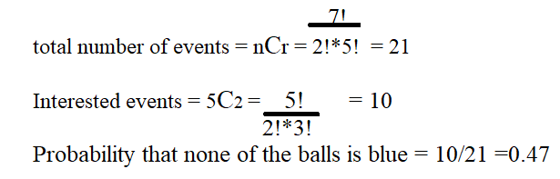

Q6) Calculate the Expected number of candies for a randomly selected child

Below are the probabilities of count of candies for children (ignoring the nature of the child-Generalized view)

|  |  |  |
| --- | --- | --- |
| CHILD | Candies count | Probability |
| A | 1 | 0.015 |
| B | 4 | 0.20 |
| C | 3 | 0.65 |
| D | 5 | 0.005 |
| E | 6 | 0.01 |
| F | 2 | 0.120 |

Child A – probability of having 1 candy = 0.015.

Child B – probability of having 4 candies = 0.2

Ans- Expected number = E(x)

= µx= 1*0.015+4*0.20+3*0.65+5*0.005+6*0.01+2*0.120 =**3.09**

Q7) Calculate Mean, Median, Mode, Variance, Standard Deviation, Range & comment about the values / draw inferences, for the given dataset

* For Points,Score,Weigh>

Find Mean, Median, Mode, Variance, Standard Deviation, and Range and also Comment about the values/ Draw some inferences.

**Ans-** 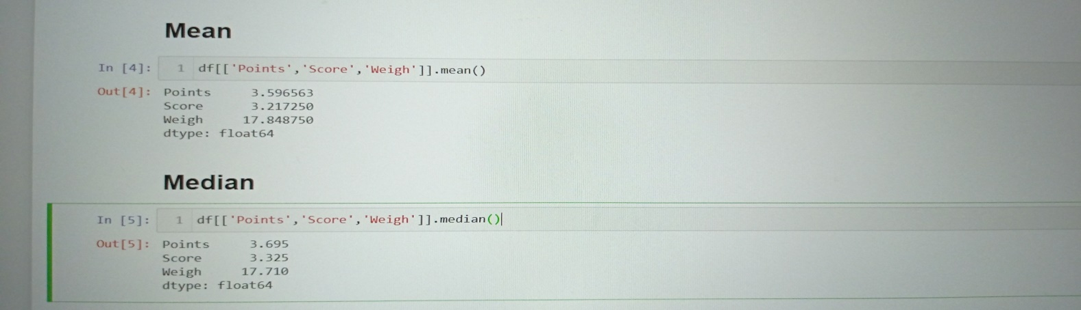

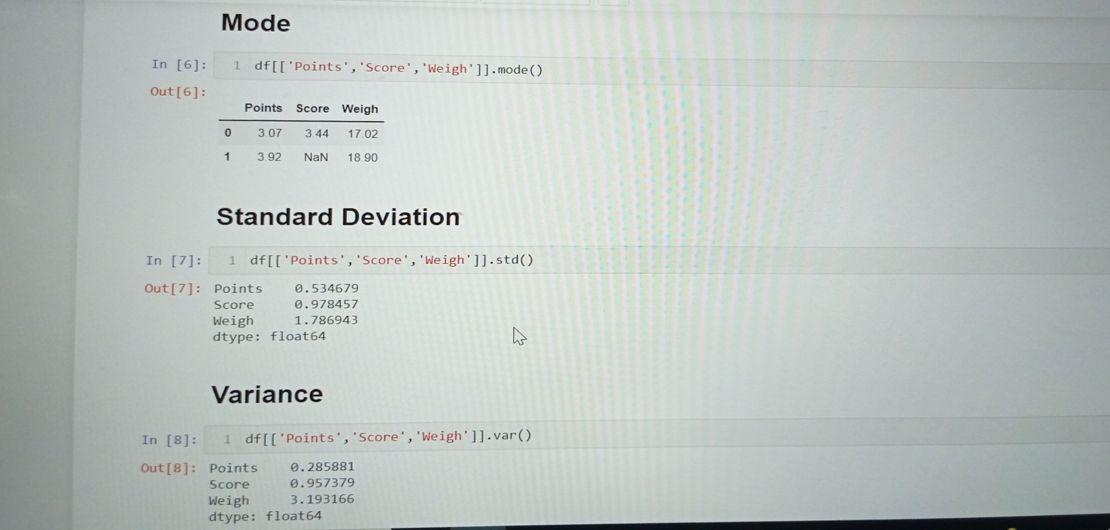

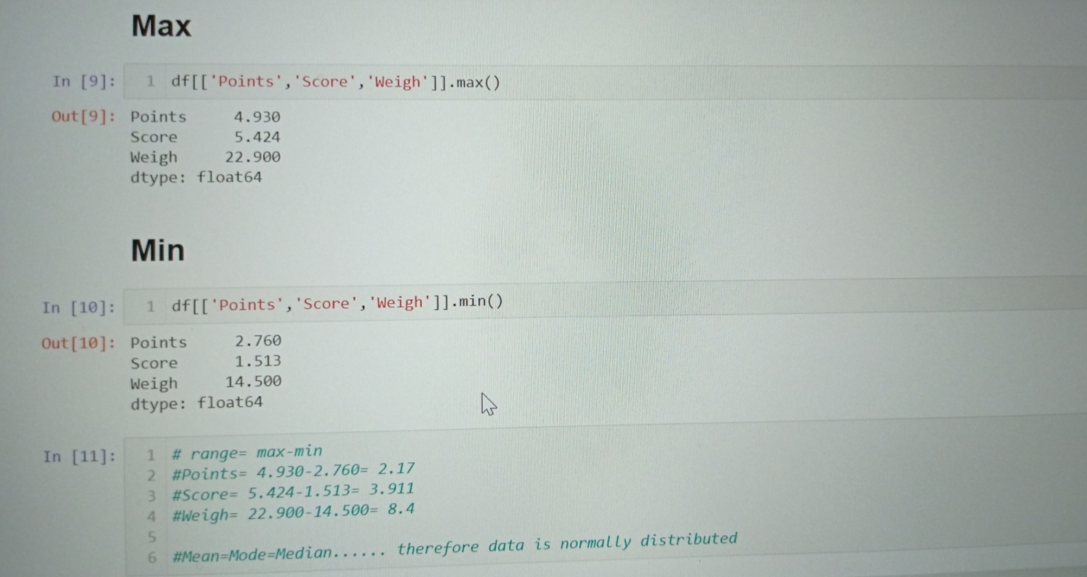

Q8) Calculate Expected Value for the problem below

1. The weights (X) of patients at a clinic (in pounds), are

108, 110, 123, 134, 135, 145, 167, 187, 199

Assume one of the patients is chosen at random. What is the Expected Value of the Weight of that patient?

Ans- 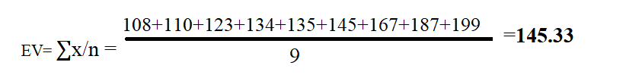

**Q9) Calculate Skewness, Kurtosis & draw inferences on the following data**

**Cars speed and distance**

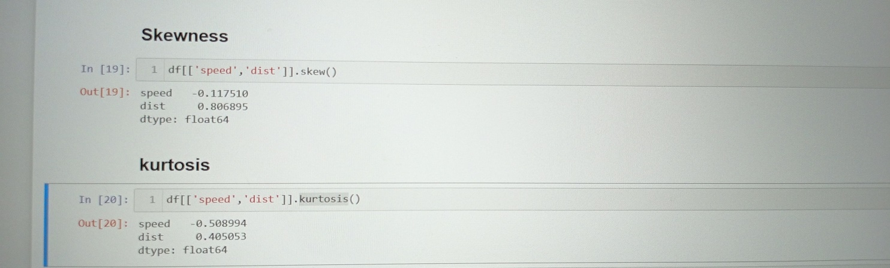

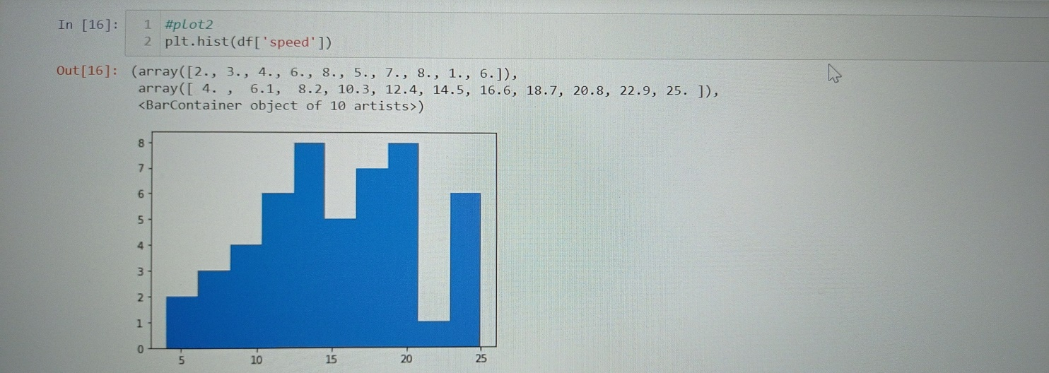

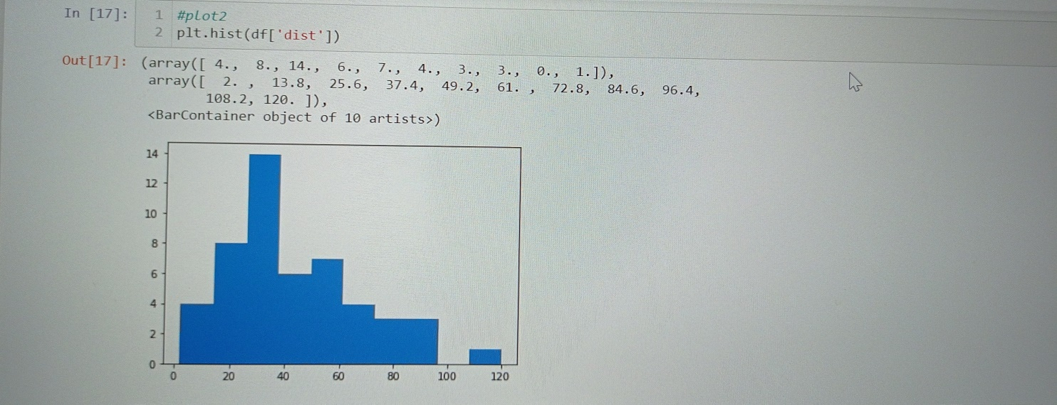

**SP and Weight(WT)**

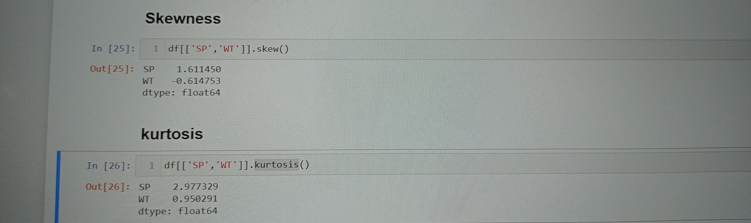

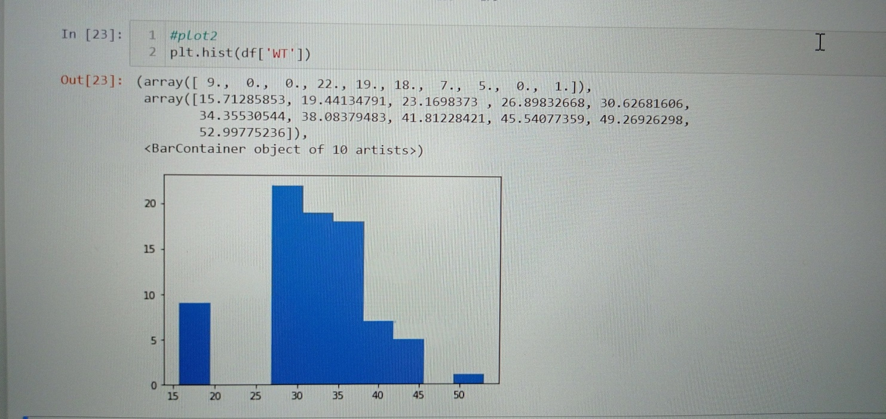

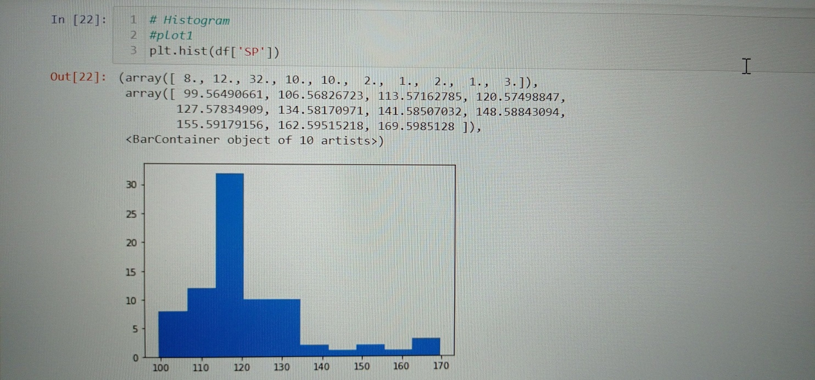

**Q10) Draw inferences about the following boxplot & histogram**



|  |  |
| --- | --- |
| Histogram | Box plot |
| This histogram shows it is right skewed data. | Right skewed data (Whisker is more on the right side of median) |
| Each column represents data within the bin. | Outliers present |

**Q11)** Suppose we want to estimate the average weight of an adult male in Mexico. We draw a random sample of 2,000 men from a population of 3,000,000 men and weigh them. We find that the average person in our sample weighs 200 pounds, and the standard deviation of the sample is 30 pounds. Calculate 94%,98%,96% confidence interval?

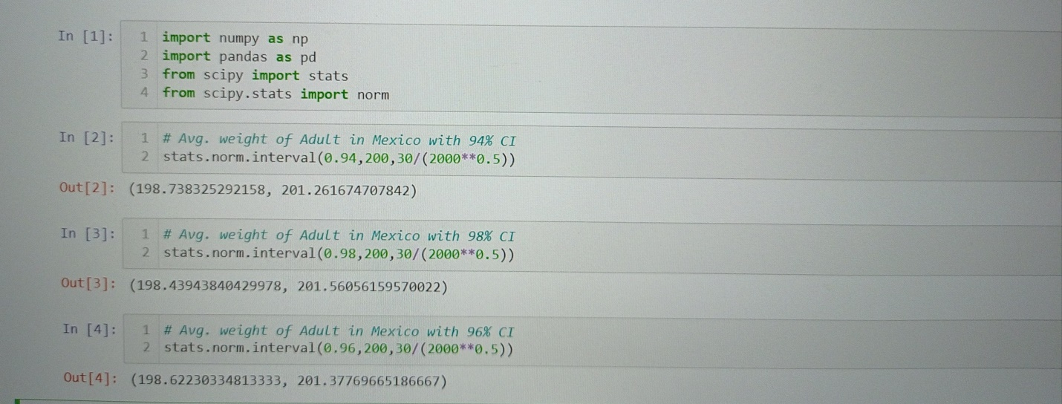

**Q12)** Below are the scores obtained by a student in tests

**34,36,36,38,38,39,39,40,40,41,41,41,41,42,42,45,49,56**

1. Find mean, median, variance, standard deviation.
2. What can we say about the student marks?

Ans- 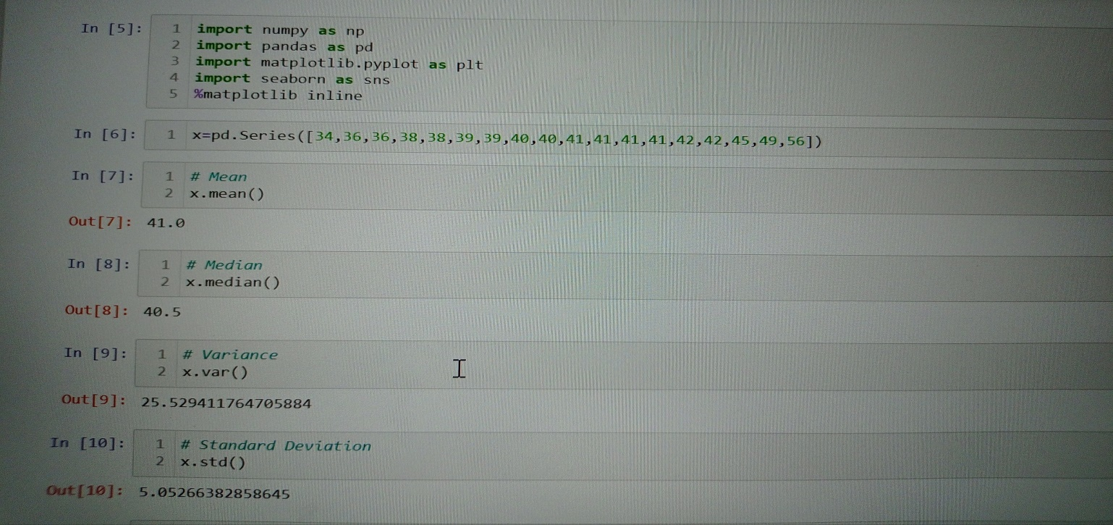

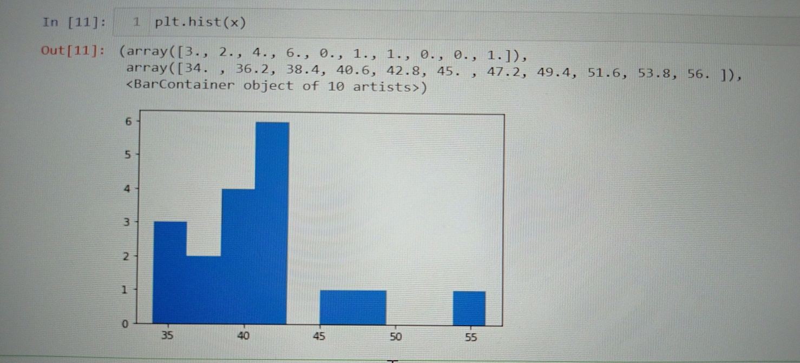

Q13) What is the nature of skewness when mean, median of data are equal?

Ans- When mean, median of data are equal,then nature of skewness is zero.

Q14) What is the nature of skewness when mean > median ?

Ans- When mean is greater than the median, the distribution is positively

skewed.

Q15) What is the nature of skewness when median > mean?

Ans- When mean is less than the median, the distribution is negatively

skewed.

Q16) What does positive kurtosis value indicates for a data ?

Ans- Positive kurtosis values indicate of that distribution is peaked and

possesses thick tails.

Q17) What does negative kurtosis value indicates for a data?

Ans- Negative kurtosis value of indicate that a distribution is flat and has thin

tails.

Q18) Answer the below questions using the below boxplot visualization.



What can we say about the distribution of the data?

* The data is not normally distributed.
* Median of the data is 15.
* No outliers present

What is nature of skewness of the data?

Ans - It is left skewed data.

What will be the IQR of the data (approximately)?   
  
Ans- IQR= Q3-Q1= 18-10=8

Q19) Comment on the below Boxplot visualizations?



Draw an Inference from the distribution of data for Boxplot 1 with respect Boxplot 2.

* Both 1 and 2 are normally distributed
* Median is same for 1 and 2. Median= Q2= 50th percentile= 260
* IQR for boxplot 1 is less compared to boxplot 2, which means the middle 50% of data for boxplot 2 spread more than boxplot 1.

Q 20) Calculate probability from the given dataset for the below cases

Data _set: Cars.csv

Calculate the probability of MPG of Cars for the below cases.

MPG <- Cars$MPG

* 1. P(MPG>38)
  2. P(MPG<40)
  3. P (20<MPG<50)

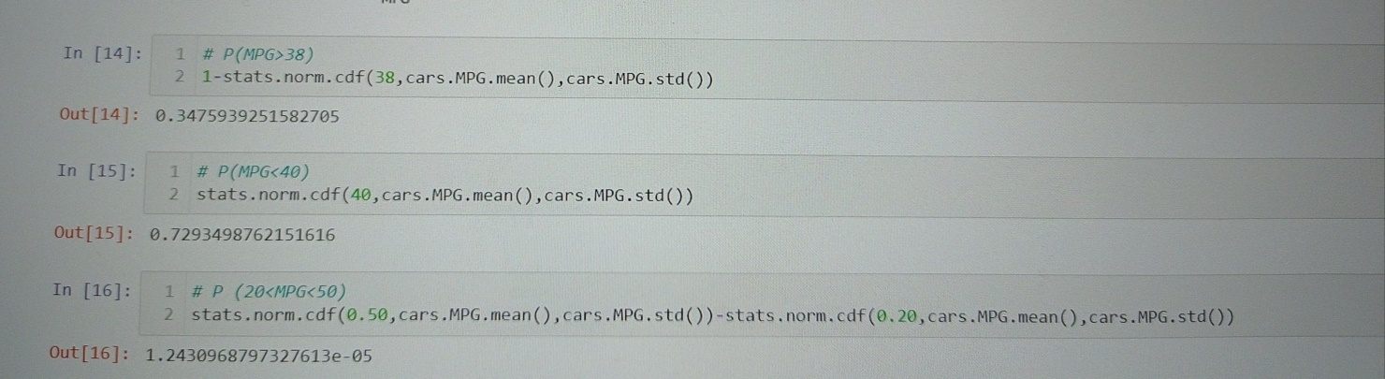

Q 21) Check whether the data follows normal distribution

1. Check whether the MPG of Cars follows Normal Distribution

Dataset: Cars.csv

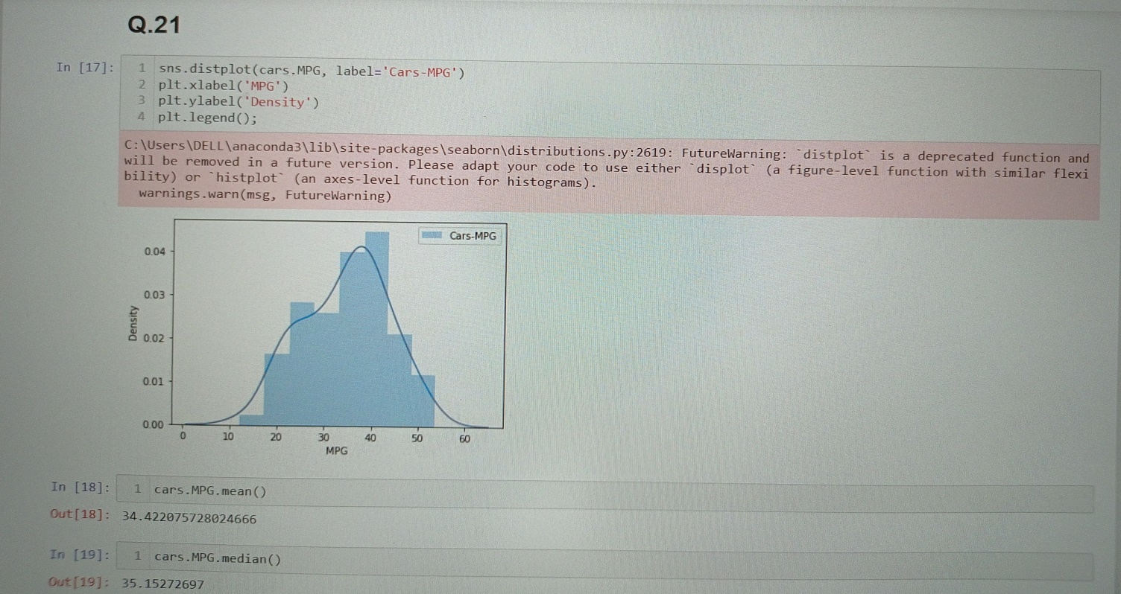

1. Check Whether the Adipose Tissue (AT) and Waist Circumference(Waist) from wc-at data set follows Normal Distribution

Dataset: wc-at.csv

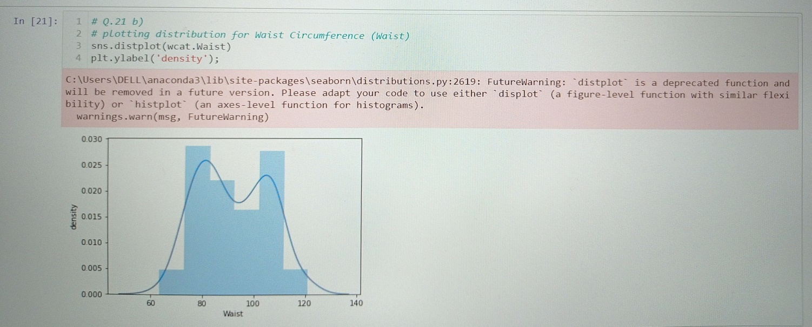

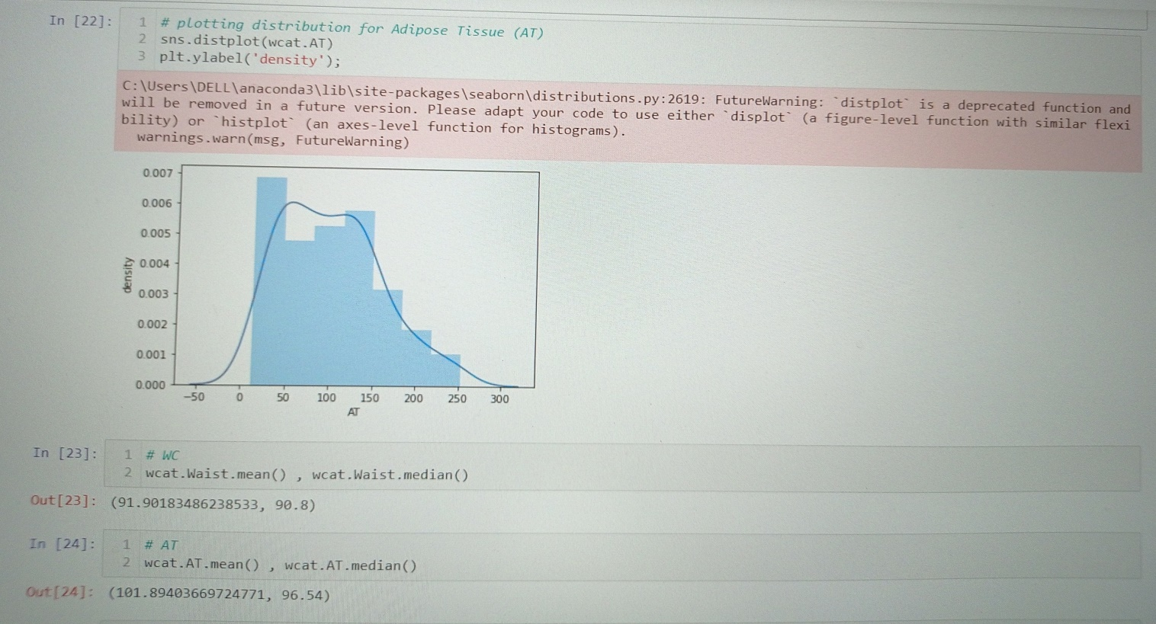

Q 22) Calculate the Z scores of 90% confidence interval,94% confidence interval, 60% confidence interval.

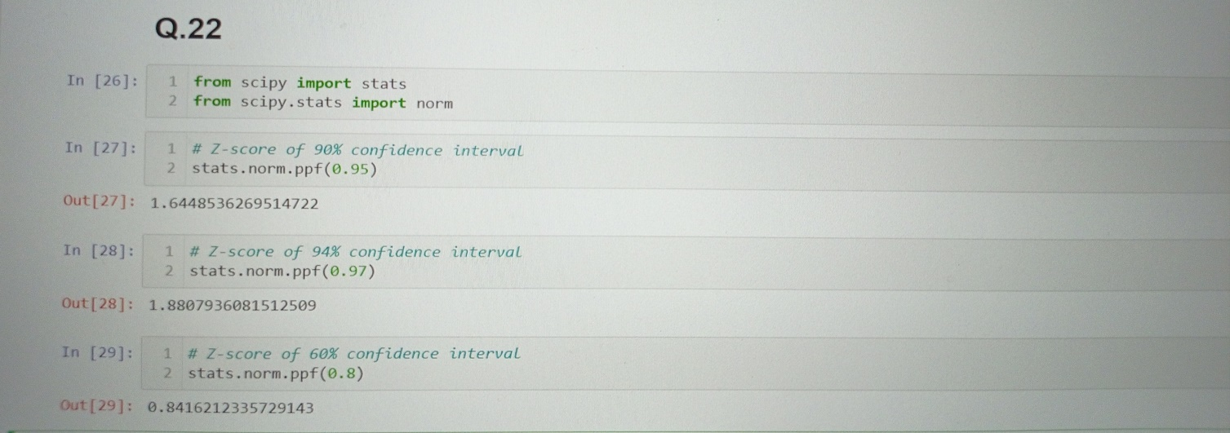

Q 23) Calculate the t scores of 95% confidence interval, 96% confidence interval, 99% confidence interval for sample size of 25.

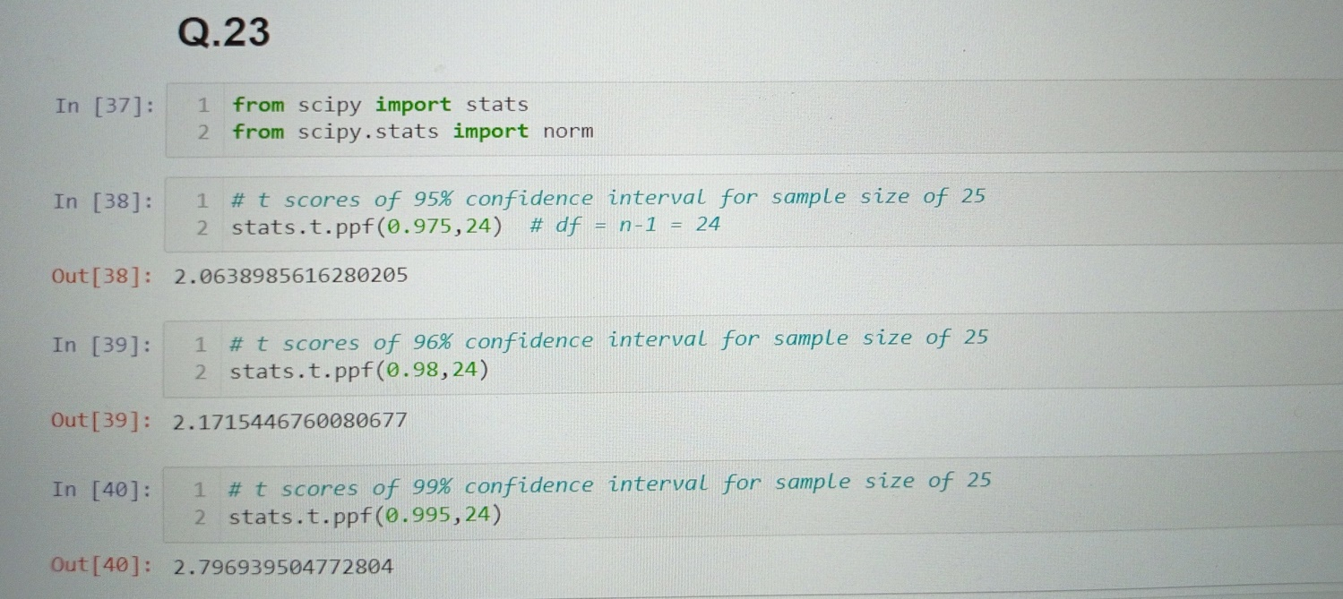

Q 24**)** A Government company claims that an average light bulb lasts 270 days. A researcher randomly selects 18 bulbs for testing. The sampled bulbs last an average of 260 days, with a standard deviation of 90 days. If the CEO's claim were true, what is the probability that 18 randomly selected bulbs would have an average life of no more than 260 days

Hint: rcode 🡪 pt(tscore,df)

df 🡪 degrees of freedom

